**Quantitative Scores:**

The graph below indicates the average score given by the eight participants on the ten questions that were asked to them. A score of five indicates that the participant strongly agreed with a statement when a score of 1 indicates that the participants strongly disagreed with a statement.

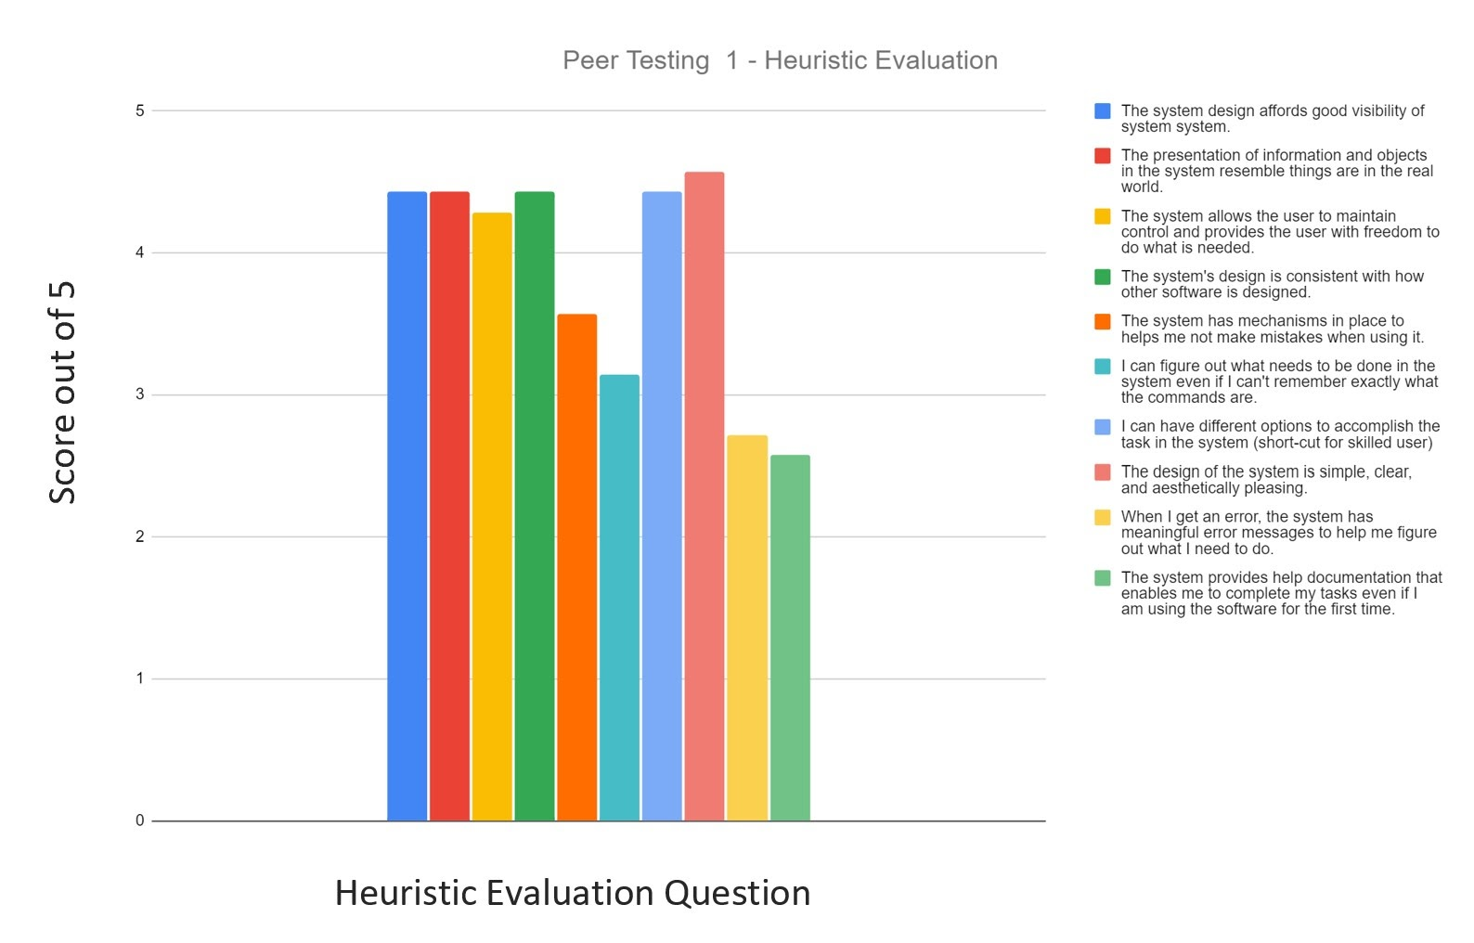

Two trends stand out from this heuristic evaluation:

1. **Provide the user with more clarity.**

The users seemed to be struggling to understand exactly what steps to take to complete the lesson. One of our participants stated, “*The instruction should be neater and simpler for new users to follow. Sometimes I cannot find the core information and tasks in the instruction.*” There was also some confusion on how to set up the lesson, “*The initial game "start" instructions felt lacking. Perhaps I missed a step but getting from the Minecraft launch title screen into the game world required a fair bit of poking around. I would like to see all the steps listed out in text, images would work as well but might lead to the page being overly verbose.*” As a result we will be providing more step by step instruction with more pictures as well as an installation and usability guide.

1. **Create a system to handle user errors.**

When the game reacts in a way the user was not expecting there is no explanation as to why something happened in an unexpected manner nor how to fix it. The users would like feedback when their code is wrong, “*You could provide some messages to tell users how to fix their errors*.” The most common feedback was for the user to be able to reset the lesson if they made an error, this was indicated by half of our participants and therefore, will be one of our most urgent priorities.